IGBO League Individual Award Program
All Spare Game, awarded to any registered member during the season who bowls an all-spare game.
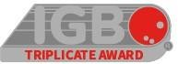
Triplicate Award, awarded to any registered member who bowls the exact same score for all three games in a series.
BIG SPLIT, awarded to any registered member who picks up one of the following: 7,10 split, 4,6,7,10 split, and the 4,6,7, (8),9,10 split (Left or right)
50 POA 140 avg or less, awarded to any registered member who bowls 50 pins over average with an average of 140 or under
75 POA, awarded to any registered member who bowls 75-99 pins or better over their average in a single game.
100 POA, awarded to any registered member who bowls 100 pins or better over their average in a single game.
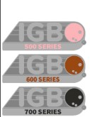 These PINS are Series awards. 500 Series (140 avg or below), 600 Series (175 avg or below), and a 700 Series.

